Generate IBKR report
- Go to TWS / Account Management Home
- Then Statements
- Then Flex Queries : And click the arrrow to execute the report over the desired period (custom range, or month to date)

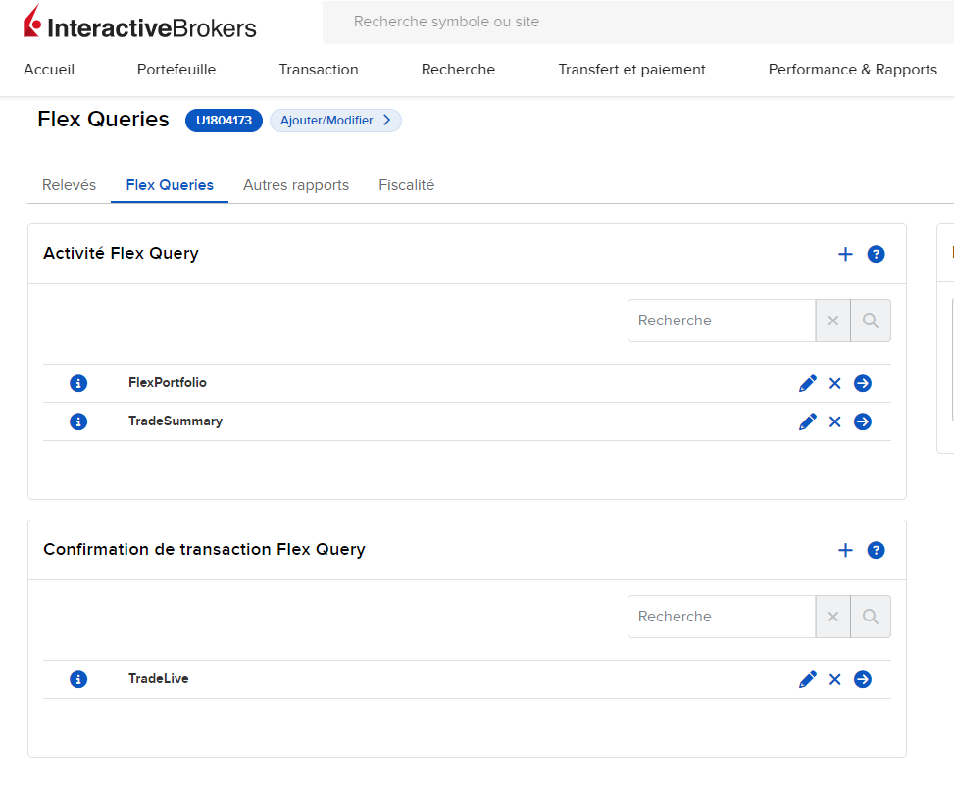
Process IBKR report
- Launch R
- Go to RReporting R project
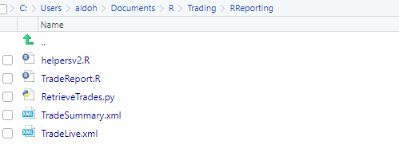
- Open TradeReport, Source file
- Select Simu or Live and then Browse to generated IBKR Report

Update Trades.xlslx
- Open in Excel Trades.xlsx
- Open a blank new Excel file
- Load new data :
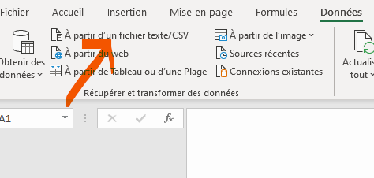

- It is possible to modify what is being loaded before uploading
- Copy and Paste (only values, no format) into Trades.xlslx desired lines
- Copy/Paste format for the new lines
Review Trades
- If new trade, provide a new trade Id, give some trade background
- If closure of trade, give some feedback, compute trade PnL

